REACT.JS COMPONENT CREATION

|  |  |
| --- | --- |
| NAME | : VATTIKUTI SRIMANTH |
| EMAIL | : vattikutisrimanth30@gmail.com |
|  |  |
| ROLL NO | : 20HU1A0449 |
|  |  |

COLLEGE NAME: CHEBROLU ENGINEERING COLLEGE

PH NO: 9346147210

Source Code:

CARD COMPONENT:

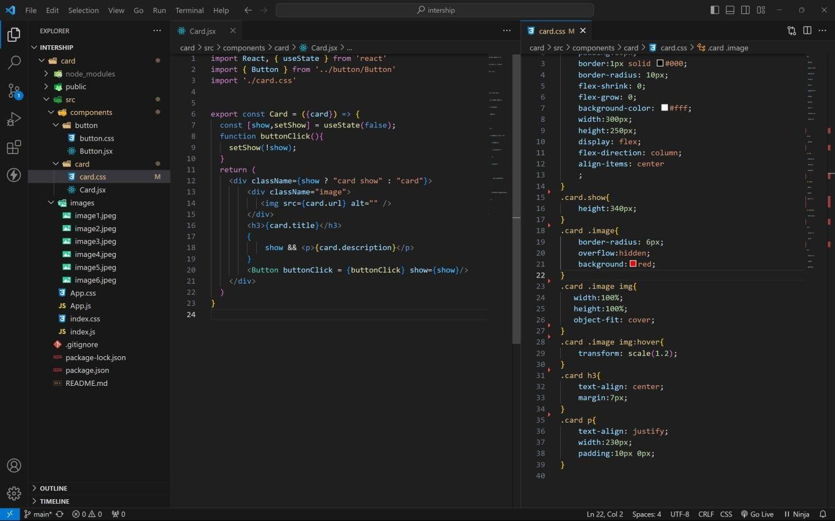

BUTTON COMPONENT:

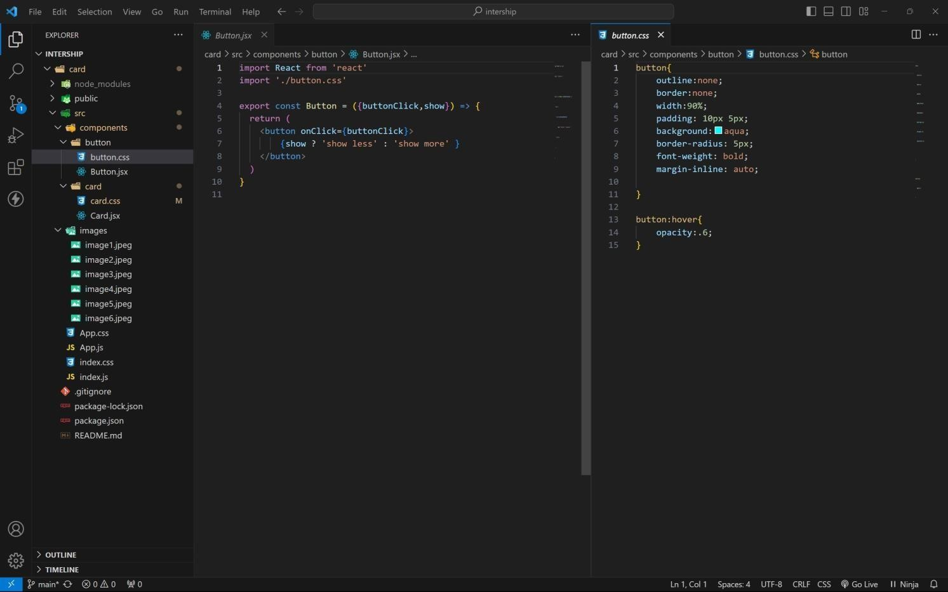

APP COMPONENT:

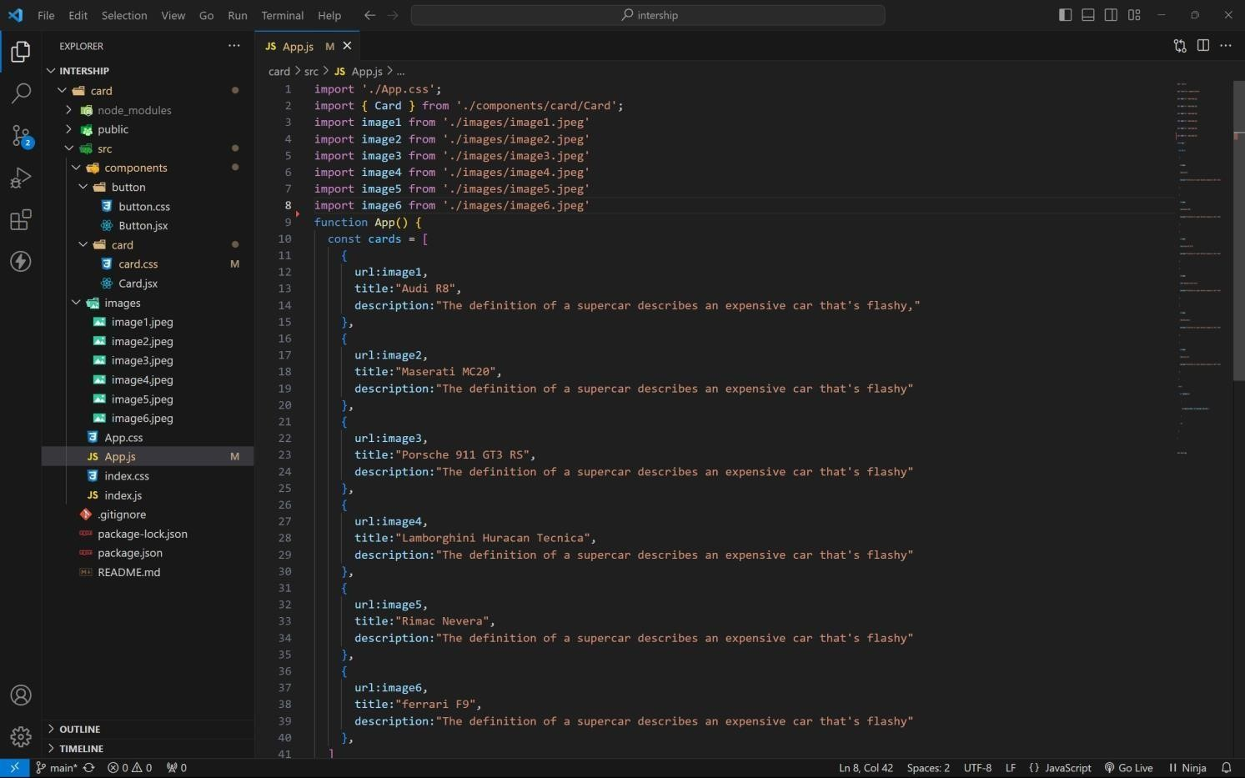

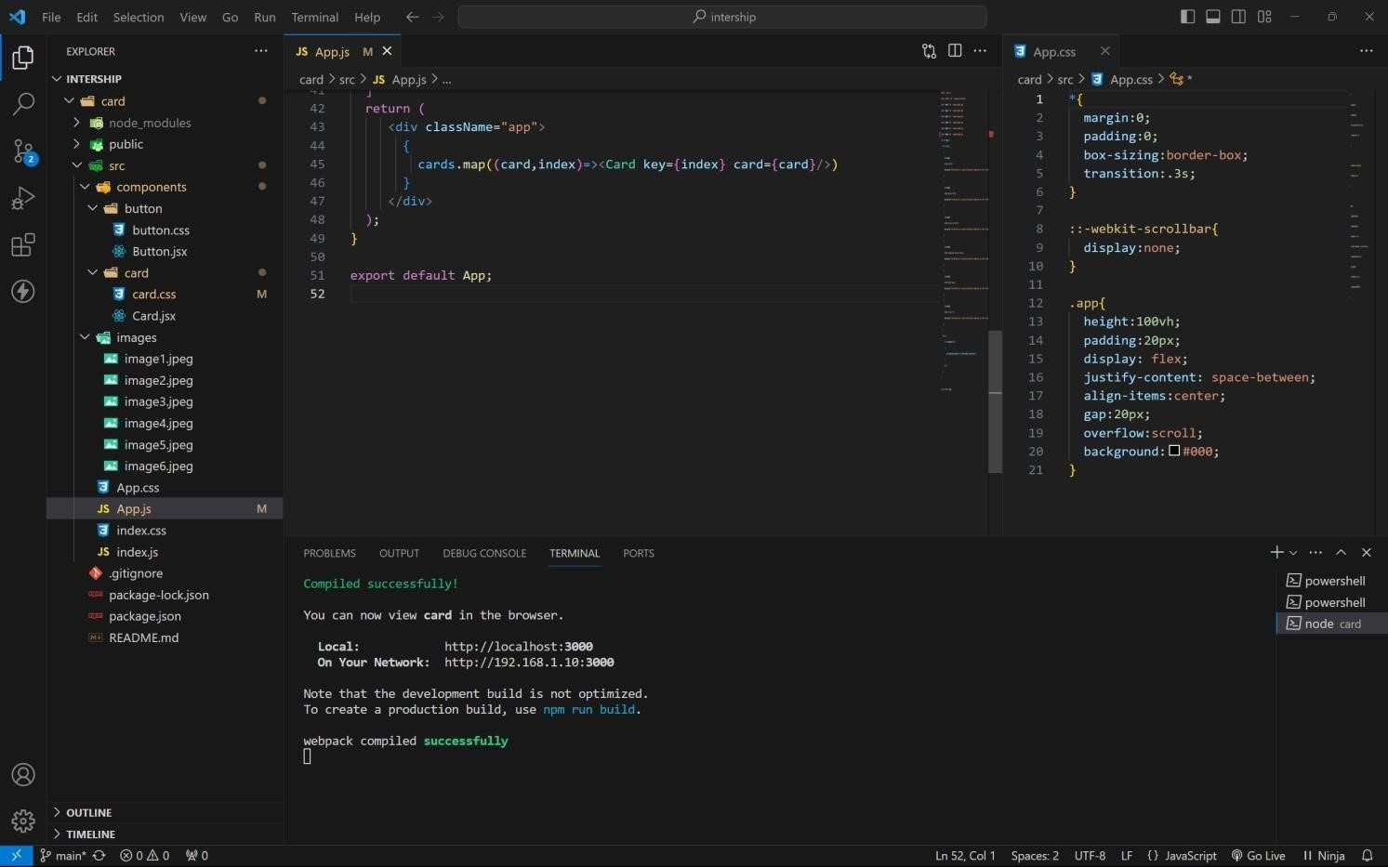

Approach:

1. . initially taking an array of objects like below

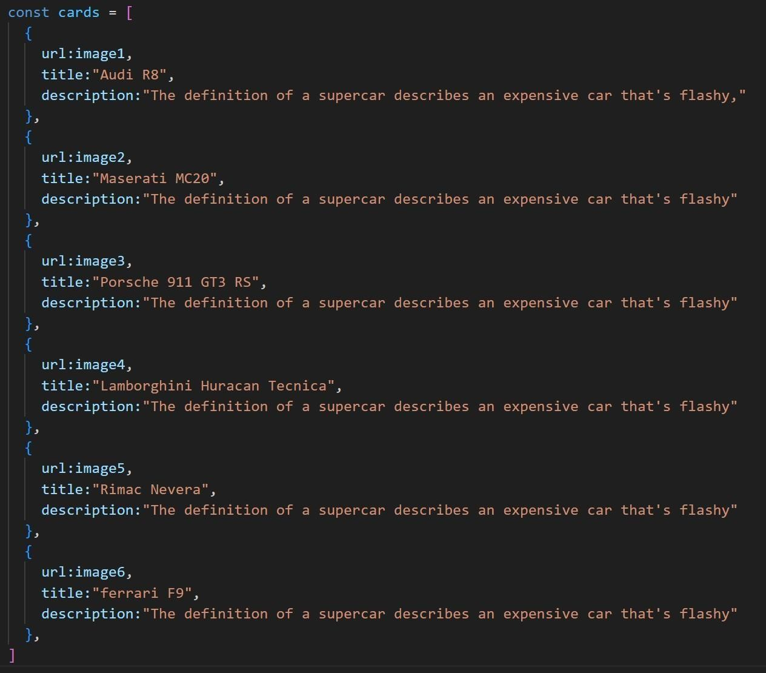

1. . Passing this card array to child (card component) of App component by using props;
2. . getting data as argument like {card} in card component.
3. . in card component i use one state [show, set Show] to get extra info as description.
4. . When we click the button then show becomes true by assigning set Show (! show).

OUTPUT:

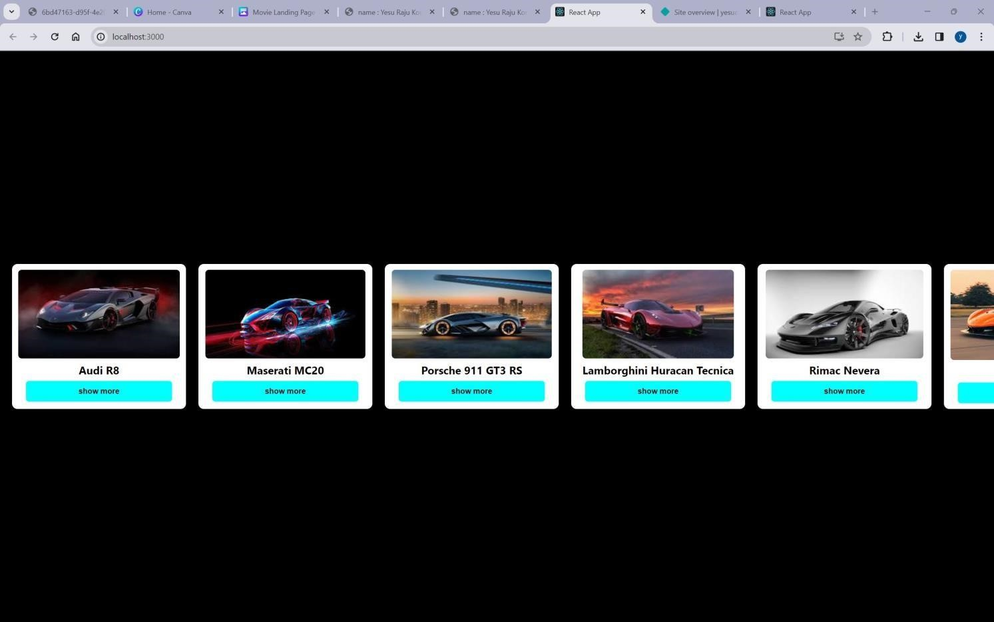

AFTER BUTTON CLICKS:

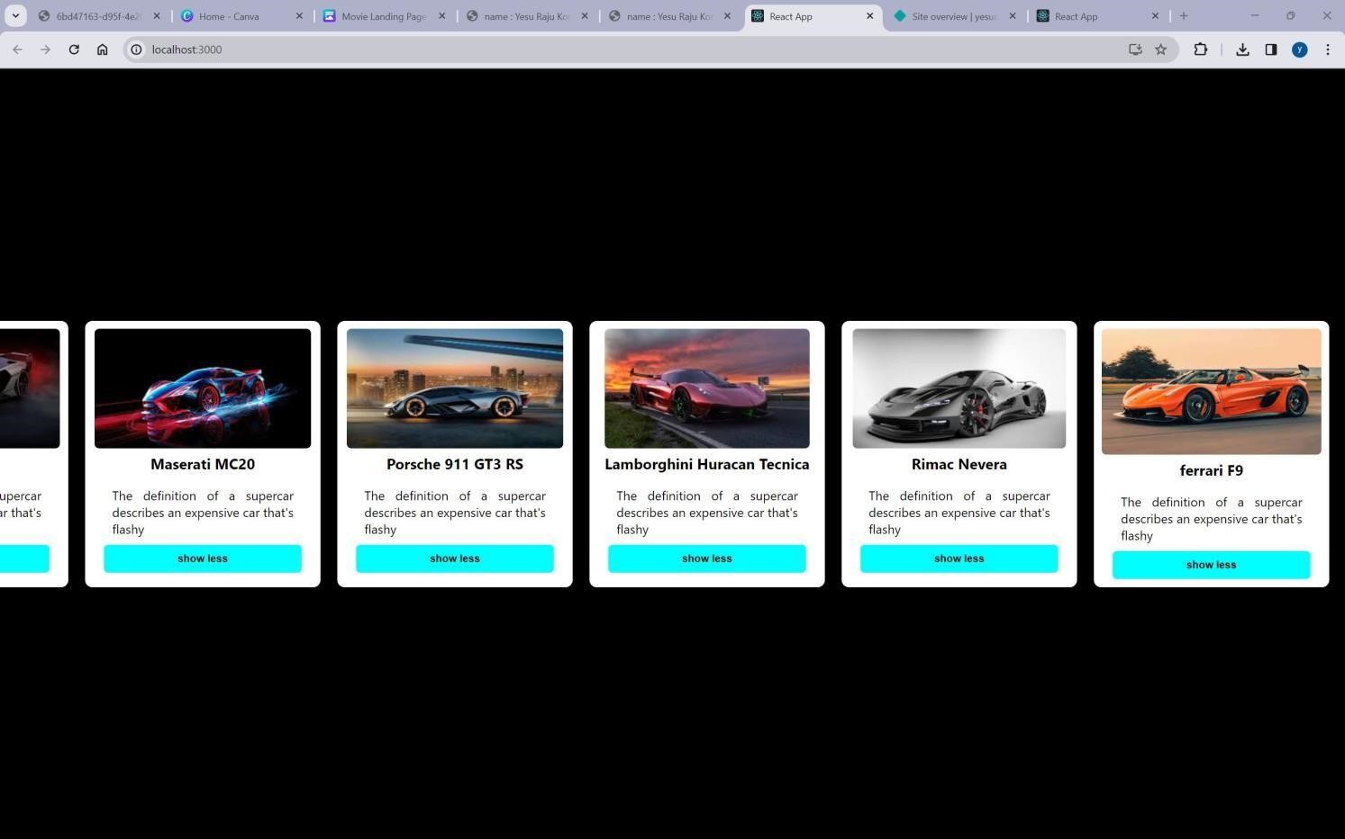

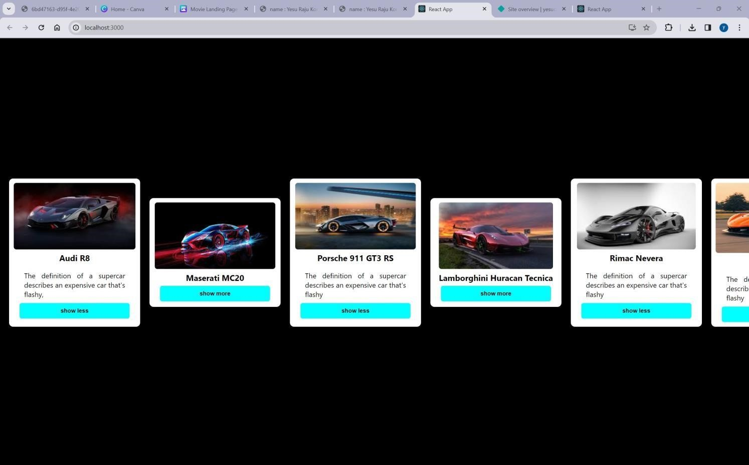

GitHub link:<https://github.com/4727yesuraju/card>live demo: [https://yesucard.netlify.app](https://yesucard.netlify.app/)